Nathanael Gage
Physics 1040
April 30, 2013
Moon Projects
Starting on the 10th to 25th of April the class was given a project to observe the moon and write down data of what was seen from a blind eye this is what I saw.
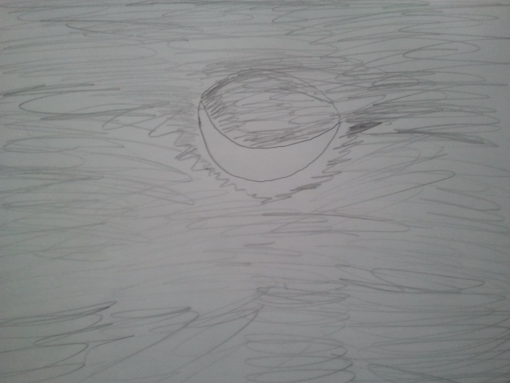
April 13, 2013 10:00pm
- Waxing Crescent
- Bright shape of where the sun was hitting it
- Vaguely see the dark side where the sun is not hitting it
- Facing East

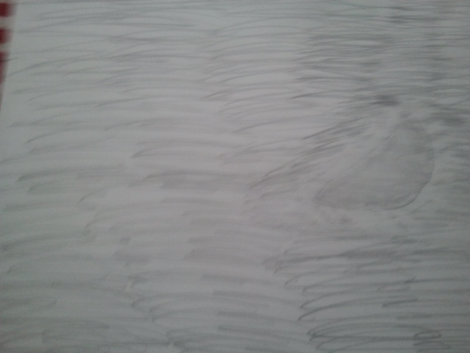
April 16, 2013 11:00pm
- First Quarter
- Lower West side
- Surrounded by clouds
- Bright outer ring of the moons shape
- Fuzzy look
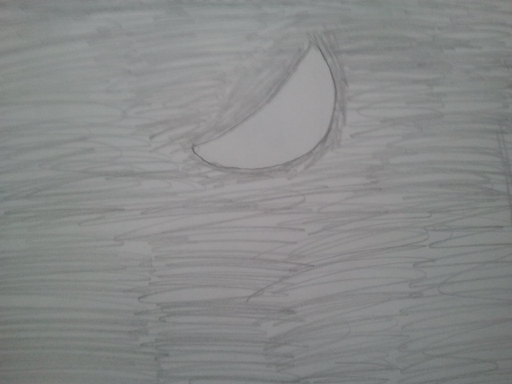
April 17, 2013 2:00 am
- Clear bright “no craters”
- First Quarter
- Slanted 20 degrees
- Facing west
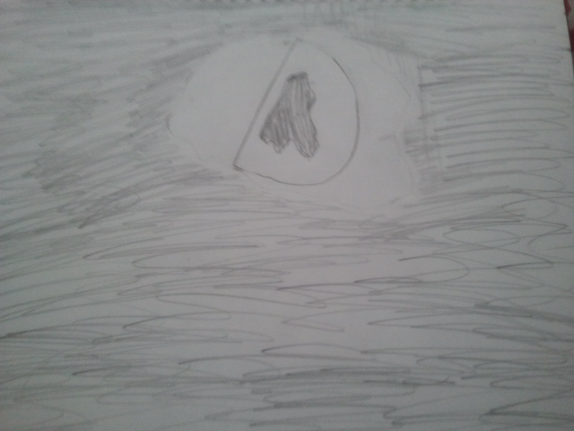
April 18, 2013 2:00 am
- Bright glare
- Mirror effect because of the brightness
- Facing west
- First Quarter
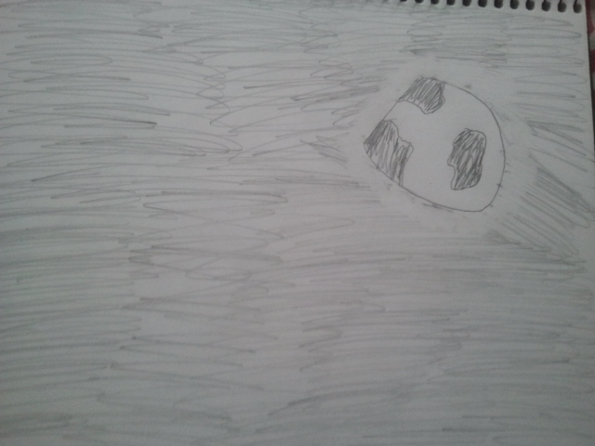
April 20, 2013 4:00 am
- Waxing Gibbous
- Facing lower west
- Bright glow
- Mirror effect but only if you stare at it for a long time
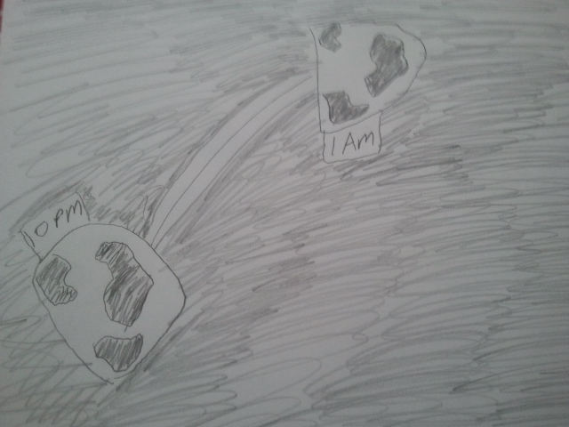
April 21, 2013 10:00 pm and 1:00 am
- Waxing Gibbous
- Moved from South to West in 2-hours
- Had more of a shine 2-hours ago
- So bright you can see a bright ring around the brightness of the moon
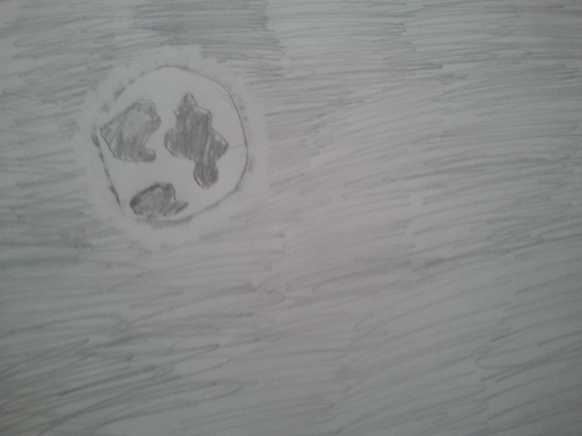
April 22, 2013 10:00pm
- Waxing Gibbous
- Lower east side
- Bright ring surrounds it
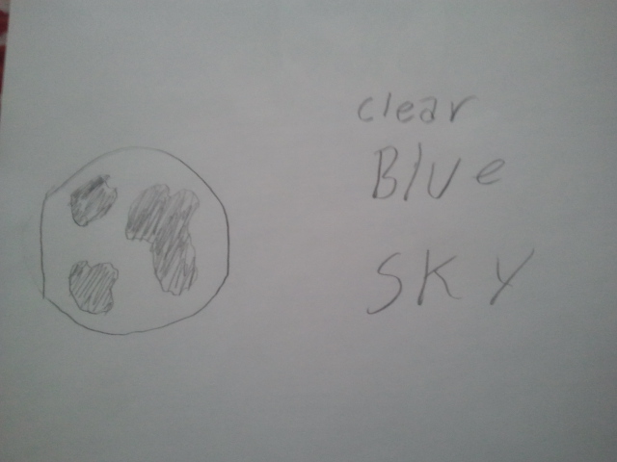
April 24, 2013 8:00 pm
- Waxing Gibbous
- Appeared when the sky was still blue
- Faded look to it
- Lower east
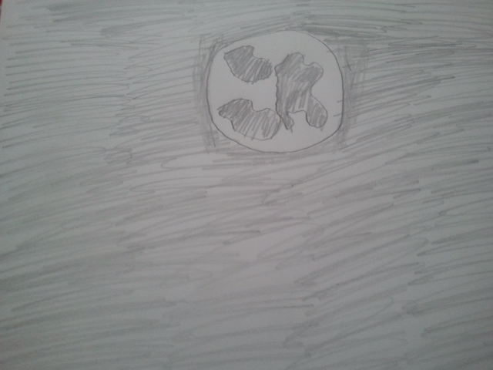
April 25, 2013 10:00 pm
- Full moon
- Bright glow
- South side
Reflective
What I have learned from the project is some things that I have not noticed before from the moon. First, I did not notice how the moon does move from east to west. Second, is when the moon changes as the sun hits it the degree angle change; example, First Quarter has a 20 degree angle contrasted to a Waxing Crescent having a 90 degree angle. Finally, the moon can be hit by sunlight so direct that it can experience bright lighted rings from our view and even have a mirror effect.
One thing that I saw interesting about the assignment is that on 24th of April the moon was out in the day light which the sun was down but at 8:00 pm the sky was blue and the moon was their faded and grey.
In conclusion in my observation of the moon many things that I took for granted and did not notice I found out in this project. I had fun with it in seeing what things I found out about of the rock that satellites the earth.

